**What is backpropagation?**

Backpropagation is a common way for an artificial neural network to figure out the gradient of the loss function for the weights. It is often used as part of algorithms that change the consequences to improve the performance of a network.

### What is SMTP?

SMTP (Simple Mail Transfer Protocol) deals with internet mail and offers important mail delivery services on the IP/TCP protocol stack. Most email solutions which send emails on the internet use SMTP to send messages from one server to another. The messages can be retrieved with an email client through IMAP or POP.

### What is the role of IEEE in computer networking?

The IEEE standards for computer networks ensure that different devices can talk to each other and work well together. They also ensure that the network service, such as the Internet and related technologies, follows a set of rules and best practices so that all the networking devices can talk to each other and work well together.

Since different kinds of companies make computer systems, the IEEE's computer society started Project 802 in 1985 to make it easier for different devices to talk to each other.

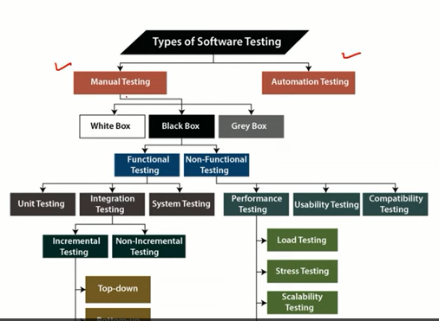

Main purpose of s/w testing?

1. Debugging
2. Verific ation & Validation
3. Execute of prog
4. All of above

White box testing means?

1. Testing without knowing by internal code structure
2. Testing by known internal code structure
3. Testing by end users

Black box testing means?

1. Testing without knowing by internal code structure
2. Testing by known internal code structure
3. Testing by end users

Alpha testing is done by ?

1. User end
2. Developer end
3. Both
4. None

What type of testing is used to verify the new code changes and don’t break the existing functionality?

1. Unit testing
2. Regression testing
3. Security testing
4. Load testing

Regression Testing:

New function or module made and added to the project, then after its working fine or not with the new changes made by developer

#### Unit Testing

Unit testing focuses on testing individual parts/units of a software application early in the SDLC. Any function, procedure, method, or module can be a unit to undergo unit testing for determining its correctness and expected behavior. Unit testing is the first testing that developers perform during the development phase.

#### Integration Testing

Integration testing involves testing different modules of a software application as a group. A software application is made up of different submodules that work together for different functionalities. The purpose of integration testing is to validate the integration of different modules together and identify the bugs and [issues related to them](https://www.loadview-testing.com/learn/makes-outstanding-load-testing-platform/).

#### Performance Testing

* Assesses the speed and scalability of the website/application.
* Identifies bottlenecks for performance improvements.
* Detects bugs that are overlooked in functional testing.
* System optimization and feature enhancements
* Ensures the reliability of the website under heavy load.

#### Functional Testing

* Makes sure that the website/application is defect-free.
* Ensures the expected behavior of all the functionalities.
* Ensures the architecture is correct with the required security.
* Improves the overall quality and functionalities.
* Minimizes the business risks associated with the website/app

Software Life Cycle :

Networks:

### PAN (Personal Area Network)

* It is the smallest network of computers.
* Bluetooth or other infrared-enabled devices could be used to connect devices.
* It has a 10-metre range of connectivity.
* It can cover up to 30 feet in diameter.
* PAN network enables a single person's personal devices to connect with each other.

### Types of PAN (Personal Area Network)

Personal Area Network is divided into two categories.

* 1. Wired of personal
  2. Wireless of personal
* **Wired Personal Area Network:** The USB is used to create a wired Personal Area Network.
* **Wireless Personal Area Network:** Wireless Personal Area Networks (WPANs) are the connection networks created by combining wireless technologies like WiFi and Bluetooth. It is a network with a short range.

### LAN (Local Area Network)

* In a small network, such as a building or a small office, systems are connected.
* LAN network is low cost.
* Token-ring technology is being used.

### MAN (Metropolitan Area Network)

* Cable TV Connection is an example of a network that can be connected within a city.
* Ethernet, ATM, Token-ring, and FDDI are some examples.
* MAN network has a wider range of applications.
* This network interface could be used to connect citizens to various organisations.

### WAN (Wide Area Network)

* A network that spans a country or a larger group of individuals.
* The WAN network connects telephonic connections as well.
* The internet is the world's largest WAN, and it is mostly utilised by government entities to handle data and information.

**Difference Between LAN, MAN, and WAN**

|  |
| --- |
|  |